303 Learning Parent Handbook
Welcome to the 303 Learning family. Our mission is to help your child become a fluent, independent reader. Along the way, we hope both you and your child will understand their learning style, inherent strengths, and gain the type of confidence that can only be achieved by overcoming obstacles.
We want 303 Learning to be a place where your child’s needs are not only understood but celebrated. It is our mission to offer you the best tutoring services and create a positive educational experience.
Please review this guide carefully and let me know if you have any questions. Thank you for letting us be a part of your child’s literacy journey!
Best,
Jeanne, Lori, Kelly, Alex, Ann, and Stephanie
What will a tutoring session look like?
Each tutoring session is 55 minutes. Sessions will either have a reading focus or a spelling focus. All sessions begin with a quick sound warm-up followed by word study instruction. During a reading focus lesson, the students will be applying the word study instruction to reading fluently. In a spelling focused lesson, the students will be using their word study knowledge to accurately spell words, phrases, and sentences. All lessons will conclude with a comprehension or fluency activity. As your child progresses with reading and spelling skills, we may add writing instruction into our lessons. Letter formation may be incorporated as needed.
Within 24 hours of your session, you will get a brief email from your tutor that details what was covered in your child’s lesson.

Do I need to stay with my child?
You are invited to watch and observe any part of the lesson. We want you to understand how we are teaching your child to read. However, your role is as observer and not co-teacher. Many well-intentioned parents can start to take over in a lesson. Please be mindful of your child’s personality. Will your presence help them, or will it make them nervous and distracted? You are welcome to wait in our lobby, aka The Siesta Center. Several parents have been known to use tutoring time to take a little nap, read novels, or just play Candy Crush. We do ask that siblings not observe the lesson. Many of our students feel self -conscious about their reading and siblings can be very distracting. They are welcome to wait in the lobby.

Will there be homework?
There is no required homework. As we get to know your child better, we may provide activities to take home that will reinforce what we are working on.
Please do not underestimate the value of reading TO your child for 10-20 minutes a night. Dyslexic children have trouble decoding text, but they often have the ability to understand what is being read to them. Reading to your child will foster a love reading, improve comprehension and vocabulary, and will help your child to transfer the skills they learn in tutoring to everyday reading tasks.
We can’t emphasize this enough. In the beginning do not force your child to read to you. You need to read them. Most of our students have very negative feelings about reading. If you force them to read, they will continue to have these negative feelings and see themselves as a non-reader. During the first few months of tutoring one of your most important jobs is for your child to begin to see reading as something positive. We will let you know when it is time to start doing partner reading with your child. When it is time to do partner reading, we will provide students with Controlled Text Readers. These readers reinforce the skills being taught during the lesson.
Many of our students require help with letter formation (printing skills). These skills can be easily practiced at home, but they require supervision to ensure that the letters are formed correctly. While children are often given instruction on letter formation in school, there is rarely enough time in the school day for students to get the necessary practice. Children with dyslexia have difficulties remembering how to spell certain words. This problem is compounded when students have to remember how to form the letters as well. Time spent learning handwriting skills is time well spent. Keyboarding does not create the same pathways as handwriting.

What is the payment policy?
Invoices are sent by email at the first of the month. Payment is due by the 10th of the month. During the school year, we use a tuition-based model. This system allows you to know exactly what your monthly payments will be. Lessons must be paid in advance via check or through Tutorbird. Please see the scale below for your tuition price.
We understand that summer is a time for vacation, sports, and camps. Therefore, in the summer, we will use a pay as you go model.
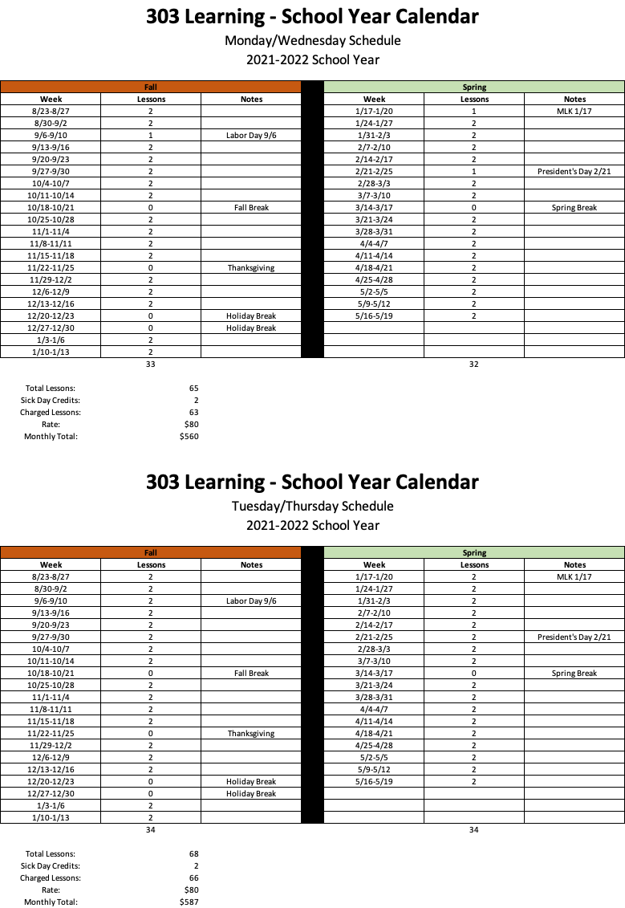

We counted the number of Mondays and Wednesdays or Tuesdays and Thursdays in the school year. We divided those by 9 to get a monthly cost. We also gave you 1 free lesson per semester. This allows for one sick day or snow day to be built into the schedule. If you have no sick days or snow days, then you get a free lesson. You may get up to 2 free lessons in a school year.

Make-up Lessons
It is our expectation that when we enter into a tutoring relationship, we will both honor that commitment to your child. Good attendance is one of the most important factors in student success.
Class fees are non-refundable. However, we understand that life happens, and we don’t want you to lose your investment. Therefore, we have created 1 complimentary day into each semester. If you have perfect attendance, you will get 2 free lessons a school year. In addition to the built-in complimentary days, make-up lessons may be scheduled on a mutually agreed upon time. Make-up lessons are offered after you have used your complimentary lesson.
If you do need to cancel a lesson, please be courteous and provide us with as much advanced notice as possible.

Weather Cancelations and School Holidays
We follow the Cherry Creek School District for snow days and holidays. However, we are open during staff in-service days. If Cherry Creek schools are closed for vacation or weather, we will be closed as well. The first snow day of a semester will count as your complimentary day. If you have more than one snow day in a semester, we will credit your account, offer a Zoom lesson, or schedule a make-up lesson.

Tutor Cancelations
You will have a regular tutor assigned to you. If your tutor is unable to attend your lesson, we will offer either a credit or a make-up lesson.

How long can I expect my child to be in tutoring?
The majority of our clients are with us 100-150 lessons. This works out to about 18-24 months.

How can I support my child’s learning?
As previously mentioned, creating a positive reading environment is one of the best ways to support your child. Audio books are an amazing resource for students who struggle with reading.
We also encourage you to learn about dyslexia. We highly recommend that all our parents read, Overcoming Dyslexia, Straight Talk about Reading, and The Dyslexic Advantage. The International Dyslexia Association also has some great resources for parents.
Be positive about dyslexia. Our most successful students have parents who point out the gifts of dyslexia; big picture thinking, creativity, athletic ability, out of the box problem solving, musical or artistic talents. And if you’re truly lucky, you’ll have a student who loves to cook. One of our former students loved making family dinners and celebrated her French heritage by making amazing pastries.

We say dyslexia
We understand that many parents have mixed feelings about the word dyslexia. They may be concerned about giving their child a label. Our students do not lack intelligence. They know they have trouble reading. We feel that the term dyslexia is a positive one. A dyslexic brain is creative, solves problems, sees the big picture, can be gifted in sports, art, music, theater, public speaking, and personal relationships. We use the label dyslexia, because too many of our students have labeled themselves as dumb, lazy, or unmotivated. We also want our students to know that dyslexia requires the adults to teach differently to meet their needs. It does not require the child to change the way they learn. Please let us know if you have strong feelings about the word dyslexia. Of course, we will do our best to respect your wishes.

With Gratitude…
Thank you for choosing 303 Learning to support your child’s literacy. We know that committing to tutoring is a big decision and we appreciate your trust in us. We hope that through tutoring your child will become a better reader and a more confident person. We look forward to sharing this journey with you.

